

**Department of Computer Science Engineering**

**SRMIST, Kattankulathur – 603 203**

**Sub Code & Name: 18CSS201J - ANALOG AND DIGITAL ELECTRONICS**

| **Experiment No** | 08 |
| --- | --- |
| **Title of Experiment** | Design and implementation of Synchronous sequential circuits using Simulation Package |
| **Name of the candidate** |  |
| **Register Number** |  |
| **Date of Experiment** |  |

**Mark Split Up**

| **S.No** | **Description** | **Maximum Mark** | **Mark Obtained** |
| --- | --- | --- | --- |
| 1 | Oral Viva / Online Quiz | 5 |  |
| 2 | Execution | 10 |  |
| 3 | Model Calculation / Result Analysis | 5 |  |
| **Total** | | **20** |  |

**Staff Signature with date**

Experiment No:8 Date:

**Design and implementation of Synchronous sequential circuits using Simulation Package**

## AIM:

To design and implementation of D Flip Flop using Multisim.

## APPARATUS REQUIRED

| **S.No** | **Apparatus** | **Type** | **Range** | **Quantity** |
| --- | --- | --- | --- | --- |
| 1) | IC | IC 7474 |  | 1 |
| 2) | LED |  |  | 4 |
| 3) | Switch |  |  | 4 |
| 4) | DC Power Source |  |  | 1 |
| 5) | Digital Clock |  |  | 1 |

**Software Required:**

<https://www.multisim.com/>

**THEORY**

A D-type flip-flop is a clocked flip-flop which has two stable states. A D-type flip- flop operates with a delay in input by one clock cycle. Thus, by cascading many D-type flip- flops delay circuits can be created, which are used in many applications such as in digital television systems.

A D-type flip-flop is also known as a D flip-flop or delay flip-flop. A D-type flip-flop consists of four inputs:

* Data input
* Clock input
* Set input
* Reset input

It also has two outputs, with one being logically inverse of other. The data input is either logic 0 or 1, meaning low or high voltage. The clock input helps in synchronizing the circuit to an external signal. The set input and reset input are mostly held low. A D-type flip-flop can have two possible values. When input D = 0, the flip-flop undergoes a reset, which means the output would be set to 0. When input D = 1, the flip-flop does a set, which makes the output

There are several applications in which a D-type flip-flop is used, such as in frequency dividers and data latches.

**PROCEDURE**

* 1. Log in Multisim Live Online Circuit Simulator.
  2. Click create circuit button.
  3. Click search for component and type components. Select it and drag to the Schematic window
  4. Select the entire apparatus given in table to complete the circuit.
  5. Click schematic connector and select junction drag to the Schematic window and left click at the point and drag to the other point to make the wire connection. Complete the connection according to the diagram.
  6. Click analysis and annotation and select digital probe and drag to the schematic window and place at the output side.
  7. Save the file by clicking the file navigation menu at the left top and save with a file name.
  8. Run the simulation change the value of the switches to verify the truth table.

**PIN DIAGRAM:**

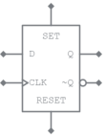

## CIRCUIT DIAGRAM:

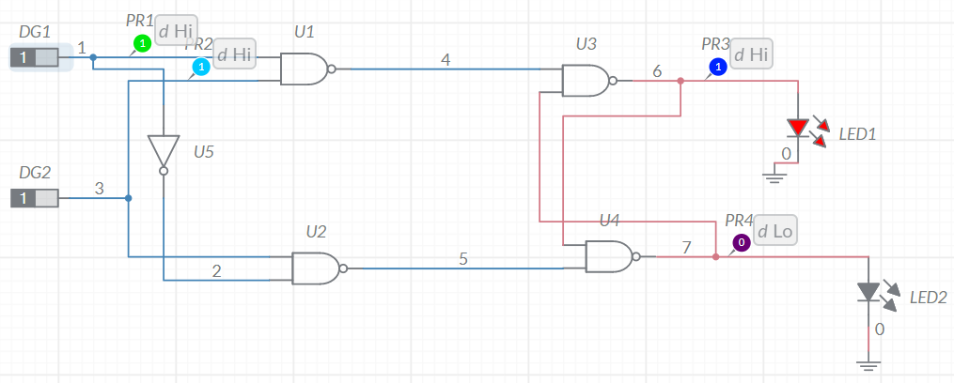

**Timing Diagram**

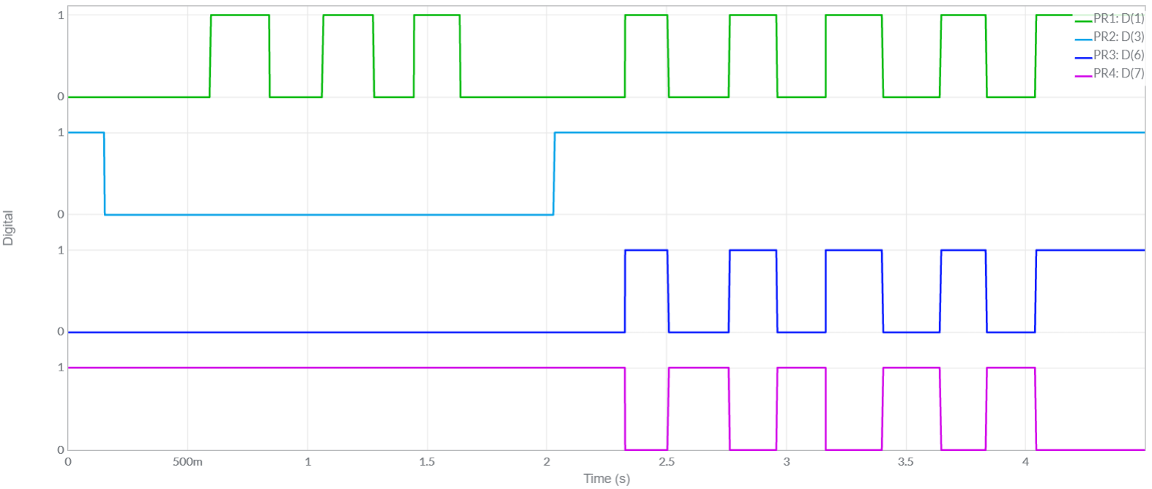

**Truth (Characteristic) Table:**

| **CLK** | **D** | **Qn** | **Qn+1** | **Q’n+1** |
| --- | --- | --- | --- | --- |
| **0** | **0** | **0** | **0** | **1** |
| **0** | **0** | **1** | **1** | **0** |
| **0** | **1** | **0** | **0** | **1** |
| **0** | **1** | **1** | **1** | **0** |
| **1** | **0** | **0** | **0** | **1** |
| **1** | **0** | **1** | **0** | **1** |
| **1** | **1** | **0** | **1** | **0** |
| **1** | **1** | **1** | **1** | **0** |

**Characteristic Equation:**

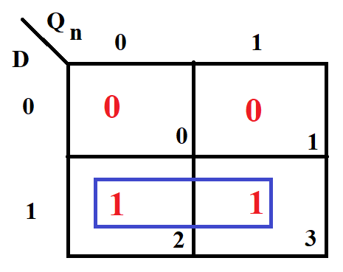

**Qn+1 =D**

## SIMULATION RESULTS

## Circuit Diagram

## 

## Timing Diagram

## 

## RESULT

Thus, the implementation of D flip flop using Multisim is verified